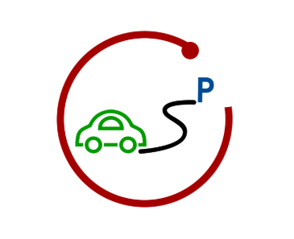

User Manual

Table of Content

1.Index Page: 1

2.Register account : 2

3. Login into website : 3

4.Booking page 4

4.1 Start with Booking Page: 4

4.2 Display Parking Area: 5

4.3 Choose Parking Area : 7

4.4 Booking process : 8

4.5 Return Back : 9

# 1.Index Page:

Start with index page via URL: <http://localhost:8080/Hweb/index.jsp>

After entering this page , you could choose register your account or sign in the website by clicking “Register” or “Sign in” button.

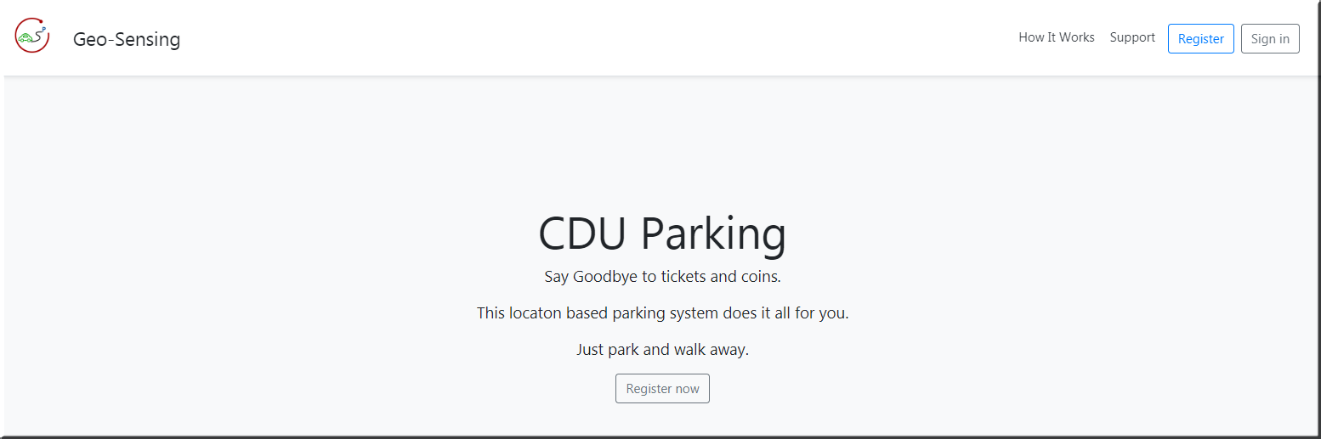

# 2.Register account :

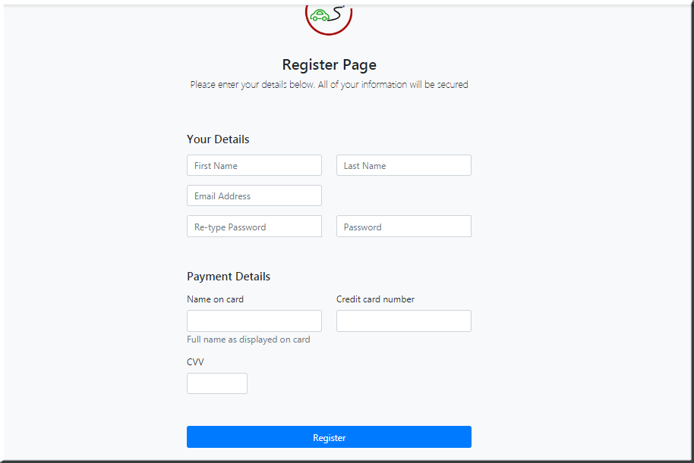

Validation of input textbox:

First Name: Only letters allowed

Last Name: Only letters allowed

Email Address: [xxx@xxx.com](mailto:xxx@xxx.com) (x represent for number or letter)

Password1: Should be same as password2 ,(length larger than 8 characters )

Name on Card: Only letters allowed

Credit Card Number: Only numbers allowed with length of 16 characters

CVV : 3 Numbers allowed

# 3. Login into website :

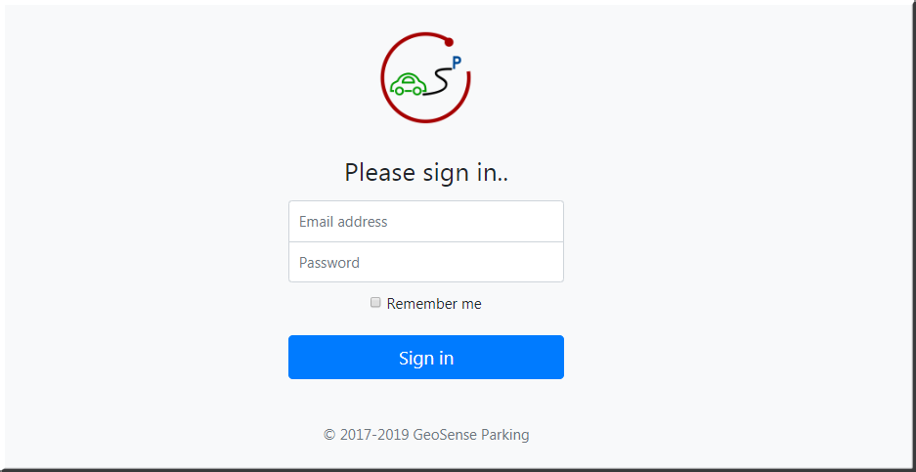

# 4.Booking page

## 4.1 Start with Booking Page:

After login into website, it starts with booking page with driver’s location shown up in the Google Map.

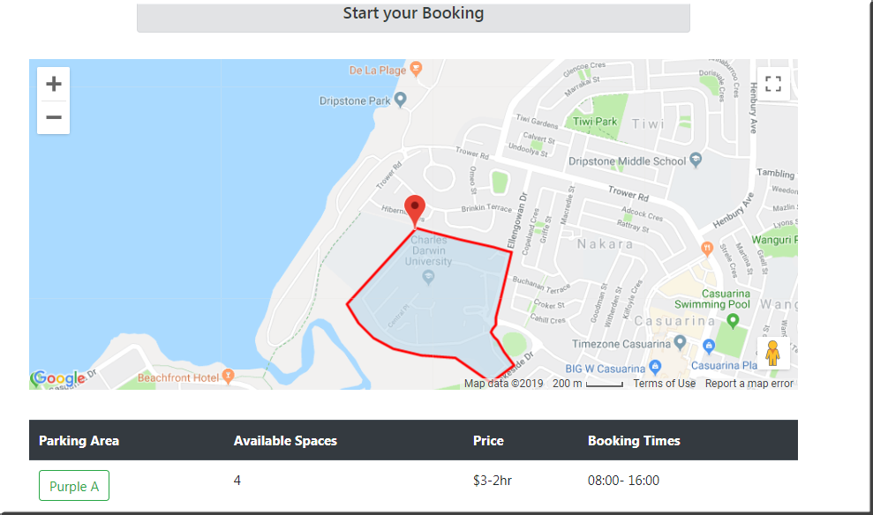

## 4.2 Display Parking Area:

Once driver gets into the CDU parking zone . The parking zone pops up automatically. Such as Purple A Parking.

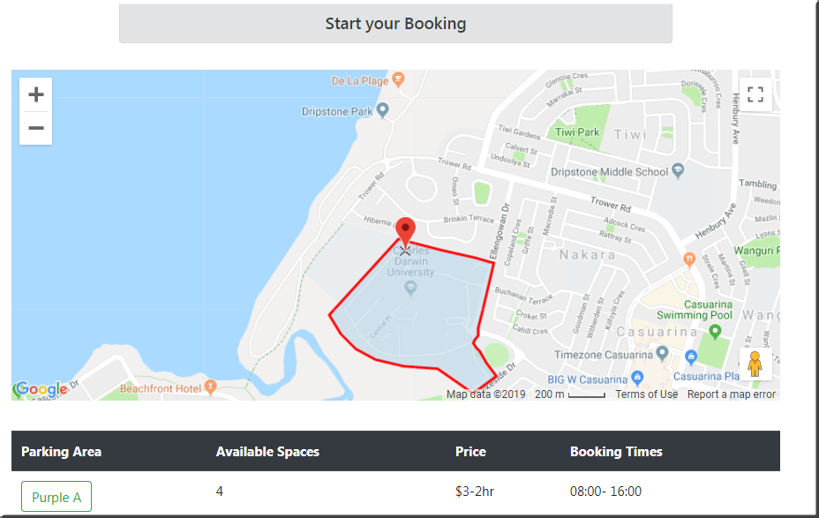

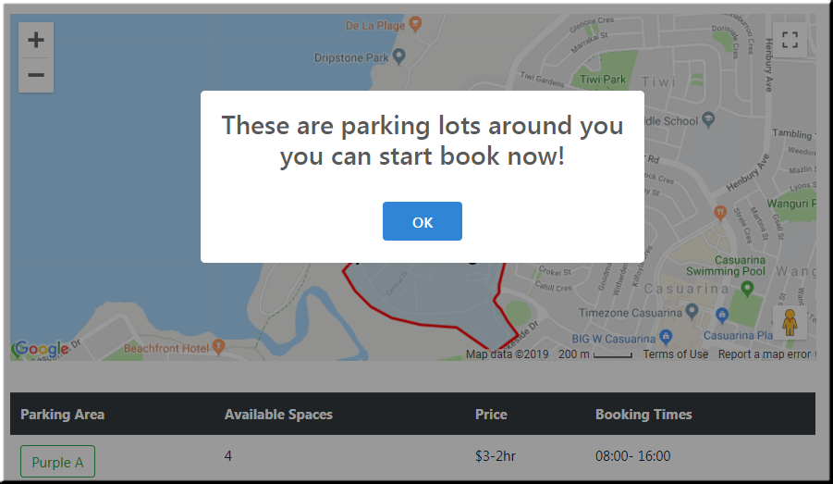

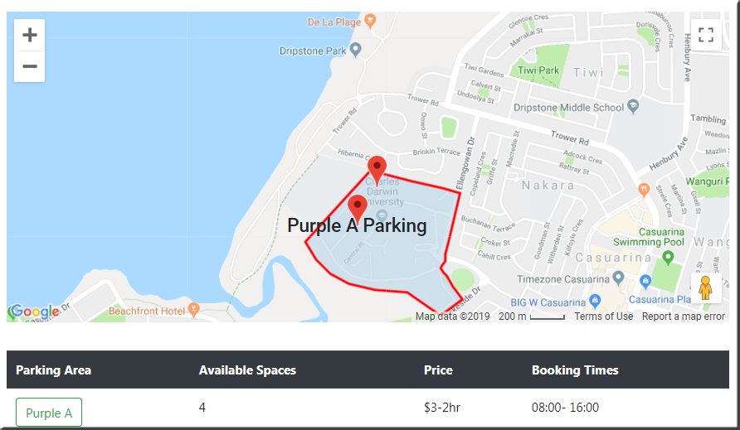

## 4.3 Choose Parking Area :

Choose parking area by clicking “Purple A”, All Purple A’s parking slots show up as well as routing direction.

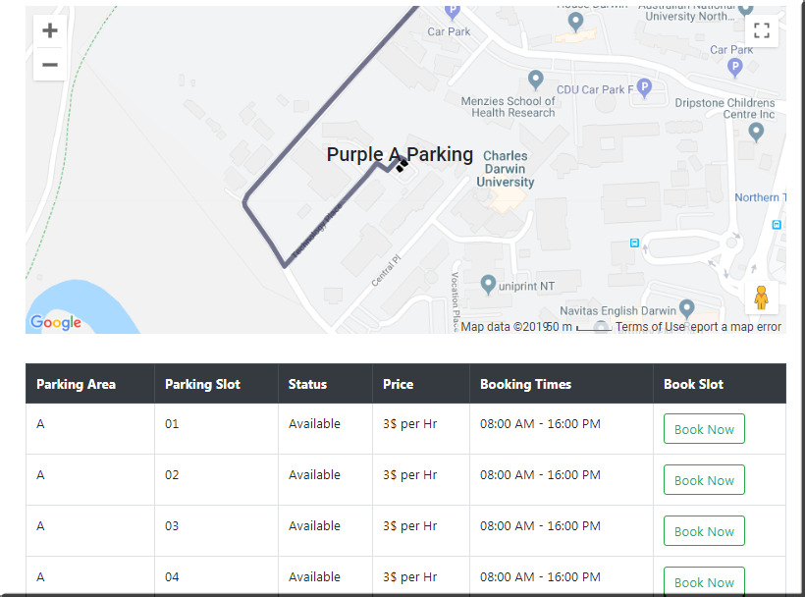

## 4.4 Booking process :

After Click on “Book Now” button, the driver will be charged according to the booking time. A receipt will be sent to the driver’s email .The status of the slot will become “Unavailable” as well as the “Book Now” button.

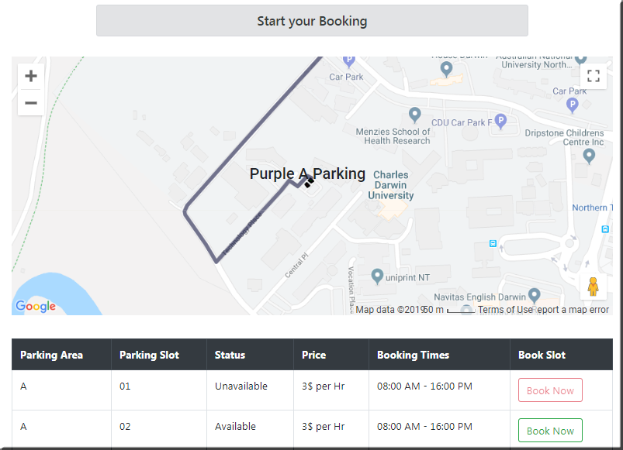

## 4.5 Return Back :

Return to booking page by clicking “Back”. It shows new number of available spaces on the booking page.

